**2.AWS-Networking Basics & IP Addressing**

**Networking basics**

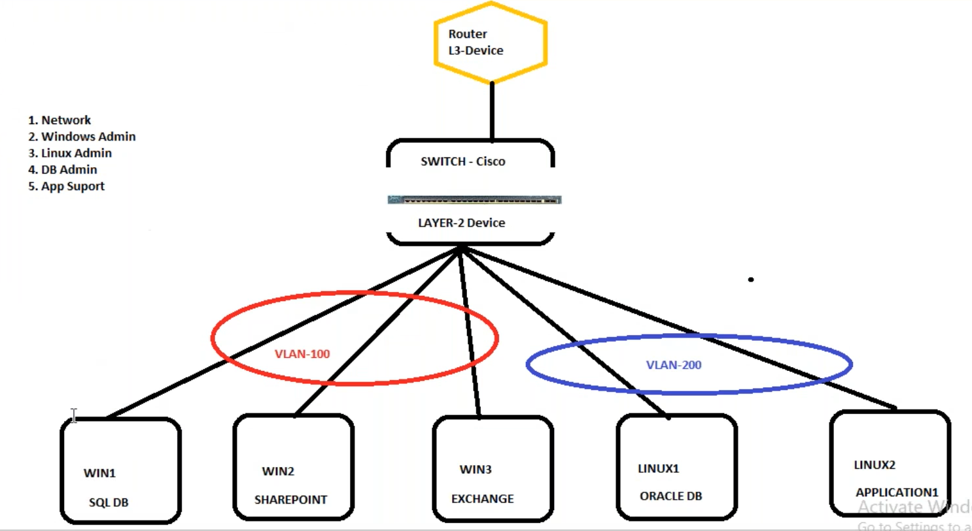

There is no connection between one VLAN to other VLAN. The VLAN are configured in layer-2-devices. By default, the servers from VLAN-100 and VLAN-200 are not communicating with each other. If you want to establish a communication from one VLAN to other VLAN, we need a device called ROUTER(l3-Device).

The communication between the subnets is established by router.

--- **switch (cisco, lauer-2devices)** – switch will provide the communication with in the VLAN-100.

--- **Router(l3-devices)** – communication with in the 2VLANS.

**IP Addressing**

--- IP address – IP address is just unique number just like a mobile number.

--- IP address are 2 types.

1.IPV4 : 32-bit

2.IPV6 : 128-bit

